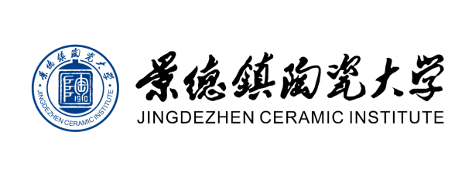
Family Name | First Name | Middle Name
Date of Birth (yyyy/mm/dd) | Sex | Email Address
Citizenship | Home Address | Contact Phone Number
Passport Number | Passport Expiry Date (yyyy/mm/dd) | Special Dietary/Residential Requests/Health Condition
Desired Date of Arrival in China (yyyy/mm/dd) | City of Arrival in China | Desired date of Arrival in Jingdezhen Ceramic Institute (yyy/mm/dd)
Date of Departure from china (yyyy/mm/dd) | City of Departure from China | Date of departure from Jingdezhen Ceramic Institute (yyyy/mm/dd)
Residency Category  ( Professional/ Studio) | Emergency Contact Person (include phone number with country code) | Relationship to Emergency Contact
Education & Work experience
International experience
Website address of personal portfolio or other site showing examples of your work.
Description of work/research you will do at JCI. Please include production methods, areas you may want to research, availability of specific tools/materials you might need, and size of work.

